**site purpose**

**the purpose for this hotel site is providing the best service we can for those of who staying to visit the temples that are connected to our hotel.**

**target audience**

**+18, those who are legally adults in America.**

**site map**

Contact us

Reservation

Temples

Home

ROOM RATES AND CONDITIONS

Temple1

Temple2

Temple3

Temple4

**color scheme**



**typography**

Girassol

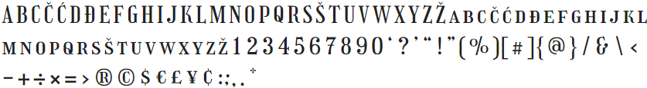

Titillium Web

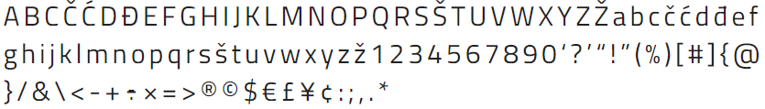

**wireframe sketches**

